CN Assignment-07

Jeetu Mehra
U24AI032

Question 1 : Construct the below network in the Cisco packet tracer and connect the server and Pcs
using DHCP protocol.
Output:
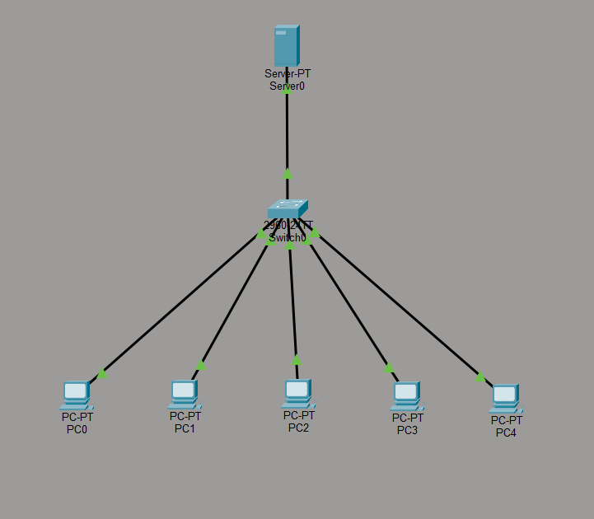

Question 2 : Construct the below network in the Cisco packet tracer and Configuring a Cisco
Router as a DHCP Server
Output:
